#### LAB 4

**THIS LAB (REMINDERS)**

* Make sure that your implementation complies with the requirements (that means: you used functions, the commands work exactly as specified, program doesn’t crash on incorrect input - provides error message instead, you have getter and setter functions, you have tests and specifications everywhere except the UI)
* All code pertaining to Assignment 3 should be uploaded on github by the time of the lab
* Have several commits with informative messages

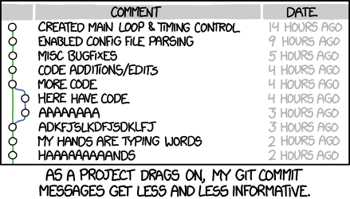

**ASSIGNMENT 4**

<https://classroom.github.com/a/idpaMKuc>

* Continue with the same problem statement you've started for Assignment 3
* Read & implement the new requirements